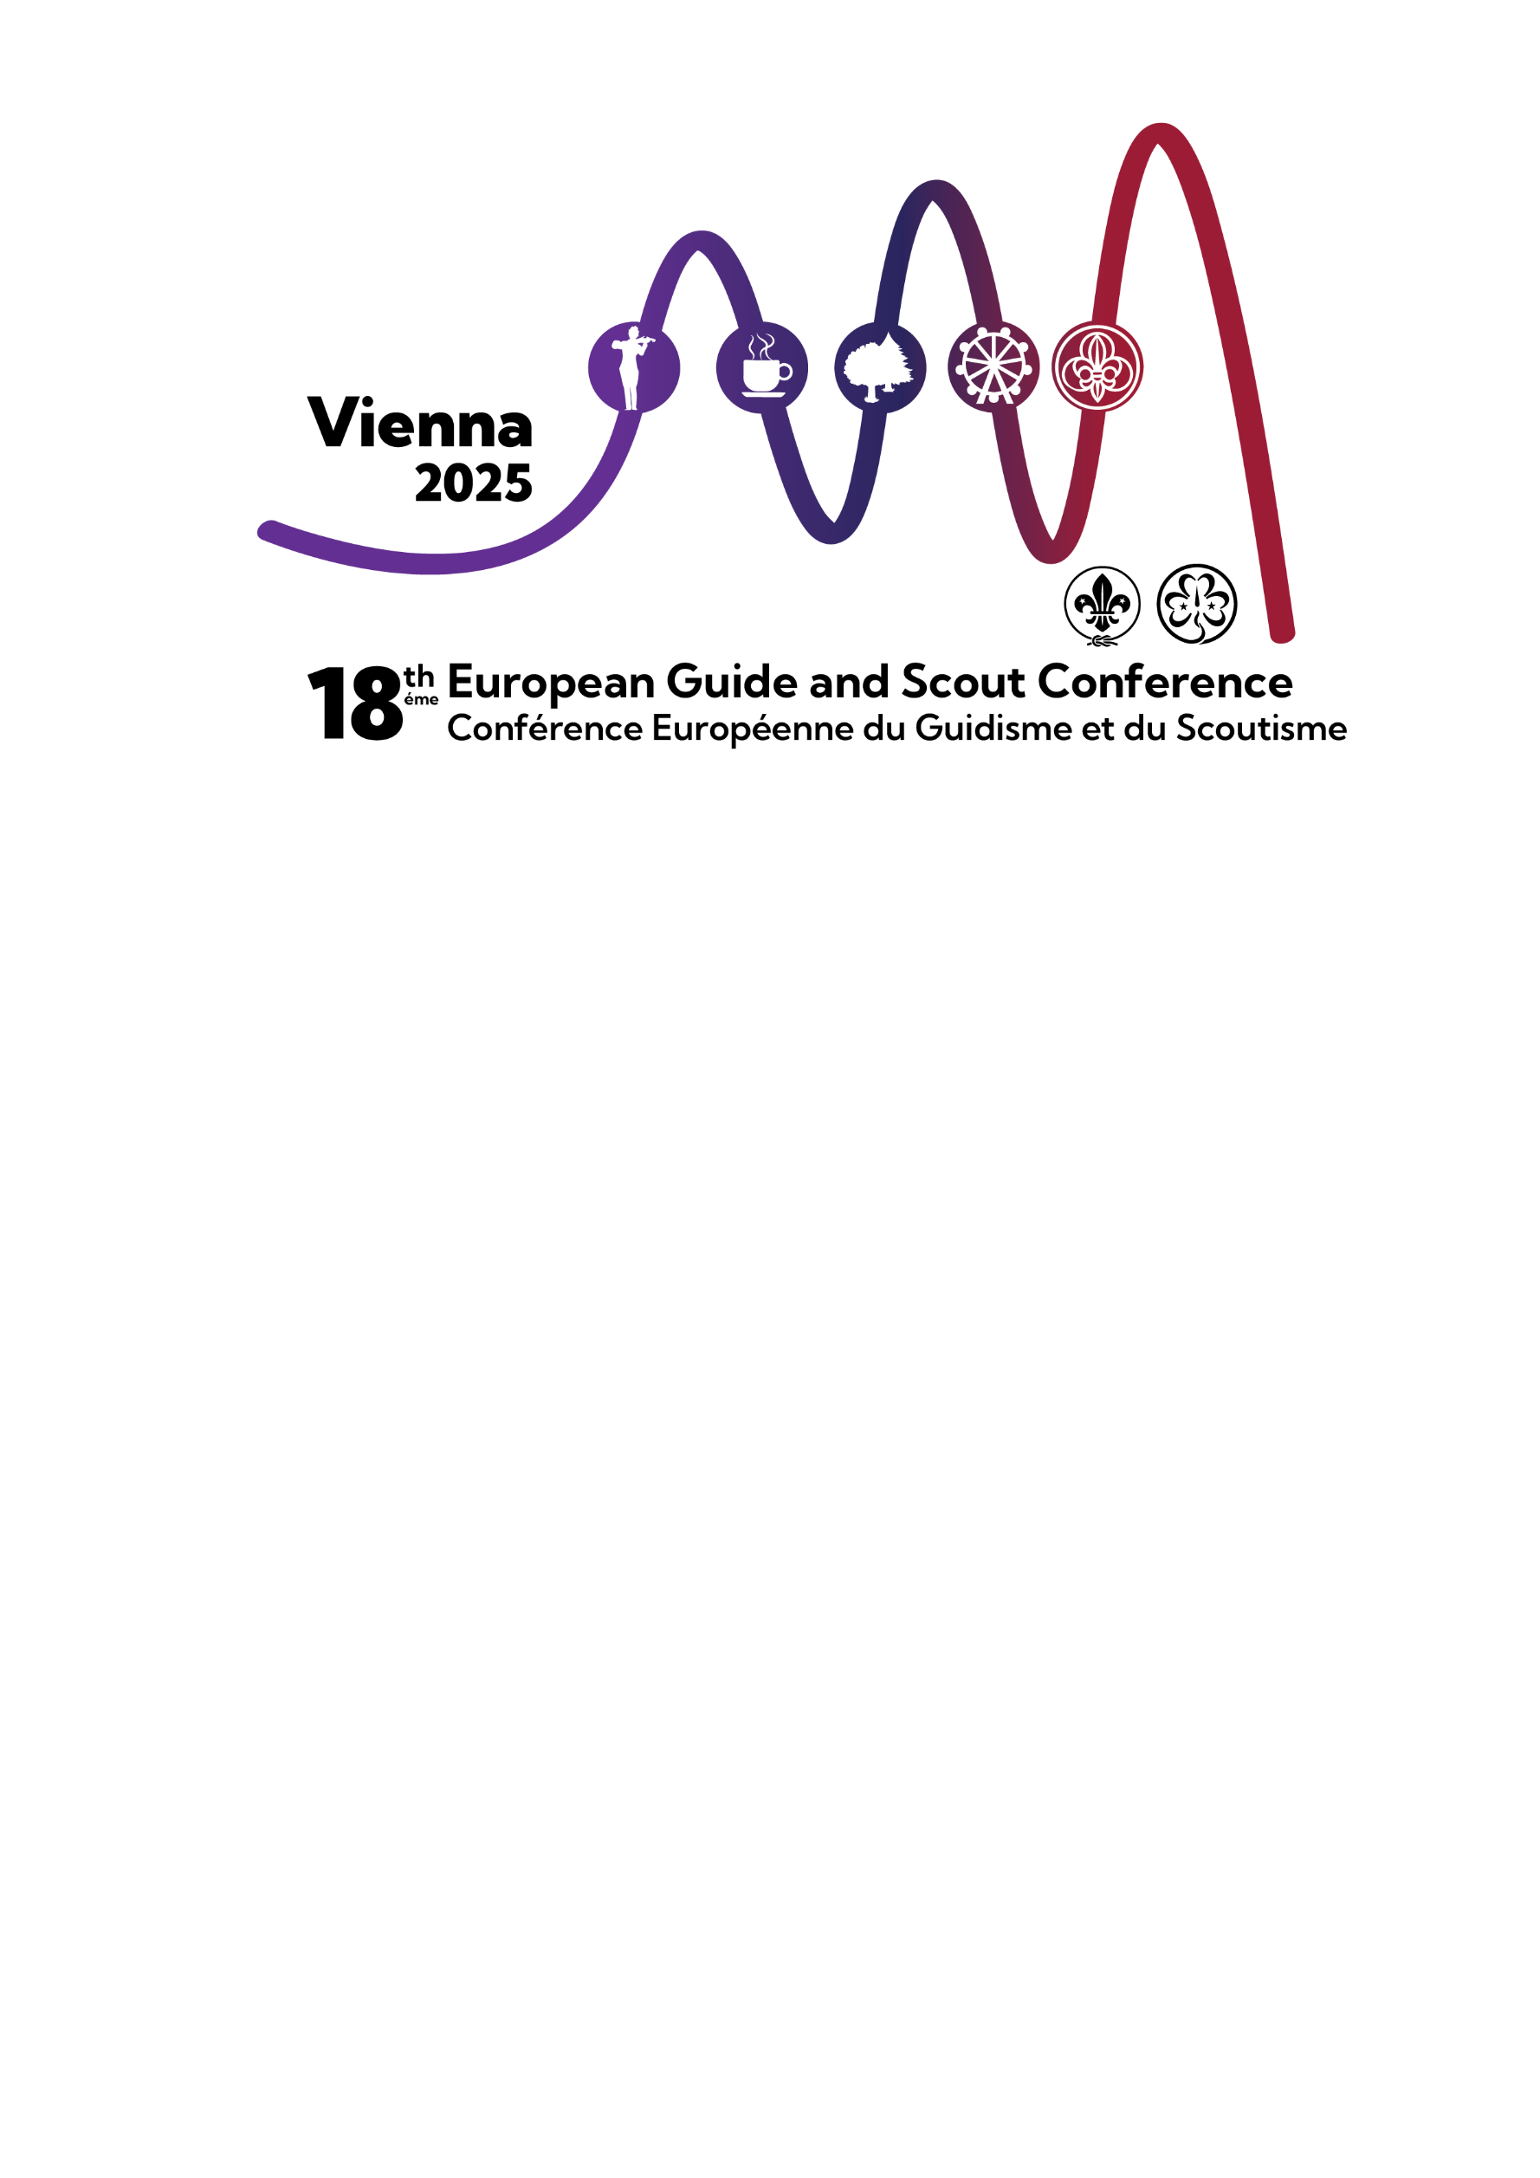

DOCUMENT

2B

Nominations Form:

Members of the Europe Regional Committee, 2025-2028

Annex 2B

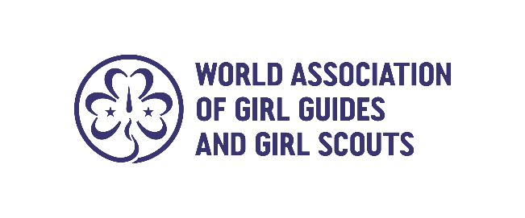
How to complete this form

How to complete this form
The nominee completes Part A and passes this to the nominating Member Organisation for its endorsement. The nominating Member Organisation then completes Part B to confirm that it approves the nomination. If the nominating Member Organisation is not the nominee’s own Member Organisation, her own Member Organisation should complete Part C.

If you have any questions about completing this form, please contact governance@wagggs.org

Submitting a nomination
The following should be returned to the World Bureau by the nominee:
- Part A of the form
- Part B of the form
- A photograph of the nominee taken within the last six months (portrait photo, facing the camera and wearing national Girl Guiding/Girl Scouting uniform, in either JPEG, PNG or TIF format)
- If necessary, Part C, the clearance form

This should be sent by email to governance@wagggs.org

Member Organisations should make clear to nominees that the nominees themselves are responsible for returning all information by 23.59 (UTC) on Monday 27 January 2025. Forms received after this deadline will not be considered.

Privacy notice
Please note that the personal information provided as part of this nomination form will be used only for the purposes of processing the nomination and will be handled by WAGGGS in accordance with UK data protection regulations.

Information will be stored by WAGGGS in both physical and electronic forms. This information will only be accessible to, and shared with, members of WAGGGS staff, members of the Nominations Committee, regional interview panels and potentially members of the World Board.

For unsuccessful candidates, information will be kept for a maximum period of one year after the closing date for nominations, after which it will be destroyed.

PART A- To be completed by the nominee

Given names (in full)
Preferred name
Family name
Member Organisation
Contact details | Main email address
 | Alternative email address
 | Main telephone number
 | WhatsApp
Date of birth (dd/mm/yyyy)

PERSONAL STATEMENT
Please indicate, in three hundred (300) words or less, why you would like to become a member of the Regional Committee, and your hopes and vision for the region in the next triennium.

SKILLS AND EXPERIENCE
The Terms of Reference for Regional Committee members outline a range of essential and desirable skills. In the following matrix and using the proposed skill level criteria and drop-down list, please indicate your proficiency in each skill and explain your reasoning. The aim is to demonstrate why you believe you possess each skill and to highlight your strengths. You can use examples and list experiences from inside and outside of Girl Guiding/Girl Scouting (locally, nationally, and within WAGGGS) as well as professional experiences, including events and courses attended, if relevant. The main point is to show why you think you have this skill needed to be a successful committee member.

Please note: Regional Committee members are not expected to have a high level of skill or experience in every area listed. The committee as a whole should encompass a diverse skillset, allowing members to complement one another. Therefore, it is acceptable for one member to be less proficient in one area while excelling in another, as the committee will benefit from a balanced mix of knowledge and skills.

Skill level criteria for rating:
- Learner: Very little knowledge or understanding and requires support to contribute to discussion in this area
- Follower: Some basic knowledge or understanding, so able to contribute occasionally, to discussions on this area.
- Contributor: Good knowledge and understanding of this area, so able to contribute fully on debates in this area.
- Expert: Extensive knowledge and/or expertise, so able to lead debates and discussions on this area confidently and competently.
- Professionally qualified: Up to date professionally or academic qualification in this area.

Essential Skills | Skill Level | To highlight your strengths, in 50 - 80 words maximum, give supporting examples by listing any relevant experience.
An understanding of WAGGGS, the complex and diverse regional context, and the varied organisational structure of MOs. | Select from list
An understanding of -and ability to articulate- the WAGGGS leadership model, and the Girl Guide/Girl Scout method. | Select from list
Good general knowledge of the challenges and opportunities facing girls and young woman across the region. | Select from list
Ability to be flexible and open to new opportunities or ways of doing things. | Select from list
Sound independent judgement and the ability to challenge constructively. | Select from list
Ability to analyse and interpret information and think critically, creatively, and strategically. | Select from list
Ability to listen and learn from others, to see things from different perspectives, and appreciate diverse points of view. | Select from list
A collaborative approach, able to work effectively as part of a diverse team of volunteers and staff while respecting different roles and reporting lines. | Select from list
Cultural sensitivity and an ability to work in a multicultural context. | Select from list
Experience in working with volunteer teams. Team leadership skills, and ability to delegate. | Select from list
Desirable Skills | Skill Level | To highlight your strengths, in 50 - 80 words maximum, give supporting examples by listing any relevant experience.
Previous experience of volunteering for WAGGGS. | Select from list
Ability to think strategically and create strategic plans. | Select from list
Financial, management, budgets, and risk management. | Select from list
Project and programme planning and management | Select from list
Governance and/or legal expertise. | Select from list
Fund development and partnerships. | Select from list
Diversity, equity, and inclusion. | Select from list
Negotiation and conflict resolution. | Select from list
Marketing and communications, including public relations and social media. | Select from list
Research and development, Monitoring and evaluation, including data collection and analysis. | Select from list
Influencing skills and advocacy. | Select from list
External relations. | Select from list
Human resources management (staff and/or volunteers). | Select from list
Information technology tools, systems and applications. | Select from list
Innovation and creative thinking. | Select from list

LEADERSHIP MODEL MINDSETS
Our leadership model is a model of leadership practice. Leadership practice is the daily behaviour you choose to engage in to put your values into action and create positive change. Leadership practice regards your “ways of being and thinking about the world” as the foundation to who you are as a leader. The best way to work on this foundation is by consciously and actively practising leadership, to develop the ten WAGGGS leadership outcomes.

Practising the WAGGGS leadership model can help leaders of the Movement develop the behaviours they need to fulfil that responsibility, so we would expect candidates for the Regional Committee to be able to demonstrate that they are consciously practising the WAGGGS leadership model through their attitudes and behaviours.

In a maximum of 300 words reply to the following question: In what ways will your practice of the leadership mindsets enhance your effectiveness as a Regional Committee Member?

VOLUNTARY POSITIONS AND PROFESSIONAL APPOINTMENTS
Please give details below of any current and past (from 2015 to today) positions that you have held within a Member Organisation, World Association of Girl Guides and Girl Scouts (WAGGGS), and professional, NGO or business appointments.

 | Current positions held  (please give the year started) | Previous positions held  (please give the year started and ended)
Member Organisation

WAGGGS (at global or regional level)

Other voluntary positions

Professional/NGO/
business appointments

LANGUAGE SKILLS
WAGGGS has four official languages: English, Spanish, French and Arabic and within each Region, depending on the local context, one or more of these may be used. In the Europe Region, the official languages used are French and English.

Please note that the ability to use English as a working language is a requirement for World Board members, therefore it is required for anyone elected from amongst the Regional Committee to undertake the role of Regional Chair. This is because an important part of the World Board’s role involves governance and ensuring compliance with UK Charity Law, and other relevant legislation or regulations.

What is your mother tongue?

Please indicate your skill in the following languages using the following key:
1: fluent; 2: intermediate; 3: basic

 | English | French | Other (please state language)
Skill level

COMMUNICATIONS
Members of the Regional Committee communicate regularly by email, WhatsApp and conference call throughout the year.

Do you currently have regular and reliable access to the internet? | Yes / No
Would you be able to respond promptly (e.g. within 48 hours) to electronic communication? | Yes / No

REFEREES
Please provide details of two referees who know you well that a member of the Nominations Committee can contact:

 |  | Referee  (professional context) | Referee  (Girl Guiding/Girl Scouting context)
Name of referee
Professional/Member Organisation (if applicable)
Role/Position held
How do they know the nominee?
Contact details | Postal address
 | Main email address
 | Alternative email address
 | Main telephone number
 | WhatsApp

NOMINEE’S DECLARATION
By submitting this nomination form, I hereby confirm that (please tick all boxes):
I accept the nomination to the Regional Committee of the Europe Region.
I agree to participate in an online interview with a panel including the regional member of the Nominations Committee and other individuals from within the region.
To my knowledge the information given on this nominations form is correct and complete.
I understand that I am personally responsible for informing WAGGGS if my contact details change after submitting this nominations form.
I understand that, if I have not received a confirmation email within 72 hours of submitting this nomination form, I am personally responsible for contacting WAGGGS to check if the nomination form has been safely received.
I understand that I have a responsibility to actively participate in the nominations process and respond to requests for information and all communications from members of the Nominations Committee in a timely manner. I understand that failure to comply with these requirements will result in an official warning being issued and may ultimately result in the Nominations Committee withdrawing my nomination.
I understand that WAGGGS will contact the referees I have provided in support of my application.
I agree to uphold the principles of WAGGGS as shown in the Constitution and its values.
I give permission, in accordance with data protection regulations, for WAGGGS to process the details in this form for the purposes of my nomination. This information can be stored both physically and electronically.
I consent to my photograph being included in the Election Booklet and understand that this will be available publicly online.
I agree to my name and photograph being used in social media posts relating to the nomination and election process for the Europe Regional Committee.

Signed (electronic signature/scan is acceptable)
Date (dd/mm/yyyy)

PART B - To be completed by the nominating Member Organisation
By signing below, I confirm, on behalf of my Member Organisation, that:
- I have read the Nominations Pack in full and Part A of this form and I believe this volunteer fits the profile described, and has the capabilities required to serve on the Europe Regional Committee.
- I understand that the nominee has a responsibility to actively participate in the nominations process and respond to requests for information and all communications from members of the Nominations Committee in a timely manner and that failure to comply with these requirements will result in an official warning being issued to her and may ultimately result in the Nominations Committee withdrawing her nomination.
- I understand that my organisation will be informed by WAGGGS if an official warning is issued and before any further action is taken.
- There are no pending investigations or disciplinary procedures related to this applicant in the Member Organisation.

Please provide any additional information (maximum 300 words) about the applicant that you would like to share with the WAGGGS Nominations Committee and relevant staff members.

Note: Completing this text box is optional. Any information you write in this text box will only be shared with the WAGGGS Nominations Committee and relevant staff members, and will not be shared publicly.

Name of Proposer
Proposer’s Member Organisation
Position held in Member Organisation
Proposer’s contact details | Main email address
 | Alternative email address
 | Main telephone number
 | WhatsApp
Signed (electronic signature/scan is acceptable)
Date (dd/mm/yyyy)
PART C - To be completed by the nominee’s own Member Organisation ONLY if it did not nominate her in Part B

REQUEST FOR CLEARANCE OF NOMINATION
Name of nominee:
Nominated by (insert name of the nominating Member Organisation):
Name of the Member Organisation to which the nominee belongs:
gives / does not give (please delete accordingly) consent for the above-named nominee to stand for election to the Europe Regional Committee 2025-2028
Additional comments (e.g. reasons for consent or non-consent)
Name
Role/Position held
Contact details | Main email address
 | Alternative email address
 | Main telephone number
 | WhatsApp
Signed (electronic signature/scan is acceptable)
Date (dd/mm/yyyy)

